भारत मौसम विज्ञान विभाग |  | India Meteorological Department
Monday 11th May 2026 (21st Vaisakha 1948 Saka)
Summary of observations recorded at 0830 hours IST: Under the influence of the upper air cyclonic circulation over Gulf of Mannar and adjoining Sri Lanka, a low-pressure area has formed over Southwest Bay of Bengal off north Sri Lanka coast at 0530 Hrs IST of today, the 11th May 2026.It persisted over the same region at 0830 Hrs IST of today, the 11th May 2026, with the associated cyclonic circulation extended upto 5.8 km above m. s. l. It is likely to became more marked during next 48 hours. A trough in easterlies ran from the centre of low pressure area over Southwest Bay of Bengal off north Sri Lanka coast to south Lakshadweep area across south Tamil Nadu between 1.5 & 4.5 km above m. s. l. The upper air cyclonic circulation over Southeast Arabian Sea & Lakshadweep adjoining Kerala coast at 0.9 km above m. s. l. persisted. The trough in easterlies ran from the cyclonic circulation over Southeast Arabian Sea & adjoining Lakshadweep adjoining Kerala coast to Marathwada across Coastal Karnataka at 0.9 km above m. s. l. The Western Disturbance seen as an upper air cyclonic circulation over North Pakistan & neighbourhood at 3.1 km above m. s. l. The upper air cyclonic circulation over West Rajasthan & neighbourhood persisted and seen at 1.5 km above m. s. l. The upper air cyclonic circulation over West Madhya Pradesh lay over Southwest Madhya Pradesh & neighbourhood and extended upto 1.5 km above m. s. l. The trough ran from upper air cyclonic circulation over Southwest Madhya Pradesh to Sub Himalayan West Bengal across East Madhya Pradesh, Chhattisgarh and Jharkhand and extended upto 1.5 km above m. s. l. The upper air cyclonic circulation over Sub-Himalayan West Bengal & neighbourhood between 1.5 & 3.1 km above m. s. l. persisted. The trough in middle tropospheric westerlies with its axis at 5.8 km above m. s. l. along Long. 88°E to the north of Lat. 23°N ran as a trough from East Arunachal Pradesh to North Bay of Bengal across Assam between 5.8 & 7.6 km above m. s. l. The upper air cyclonic circulation over northeast Bangladesh & neighbourhood lay over South Assam & neighbourhood and extended upto 1.5 km above m. s. l. A fresh Western Disturbance is likely to affect Northwest India from 15 May 2026. The trough in middle and upper level westerlies with its axis at 7.6 km above m. s. l. ran from northeast Bihar to central parts of Coastal Andhra Pradesh across Jharkhand, Odisha & Chhattisgarh became less marked at 0530 hrs IST of today. The north-south trough ran from north Pakistan and adjoining Punjab to Marathwada across upper air cyclonic circulation over southeast Rajasthan & neighbourhood, Madhya Pradesh & Madhya Maharashtra became less marked at 0530 hrs IST of today.
Maximum Temperature Departures (as on 10-05-2026): markedly above normal(> 5.1°C) at isolated places over East Rajasthan. appreciably above normal(3.1°C to 5.0°C) at most places over West Rajasthan; at isolated places over Coastal Andhra Pradesh & Yanam and Telangana. above normal(1.6°C to 3.0°C) at many places over East Madhya Pradesh and Coastal Karnataka; at most places over West Madhya Pradesh and Konkan & Goa; at few places over West Uttar Pradesh and Lakshadweep; at isolated places over Tamil Nadu, Puducherry & Karaikal and North Interior Karnataka. near normal(-1.5°C to 1.5°C) at many places over East Uttar Pradesh, Chhattisgarh and Kerala & Mahe; at most places over Himachal Pradesh, Rayalaseema and South Interior Karnataka. The highest maximum temperature of 46.8°C was reported at BARMER (RAJASTHAN).
Preliminary Earthquake Report: An earthquake shock of Modrate intensity at its origin with epicenter at Lat. 20.399° North and Long. 94.030°East, 260 km. SW of Burma; Myanmar; India; about 2121 kms away from Pune, was recorded by the seismographs in the meteorological Office Pune at 06 Hrs. 38 Min. 24Secs. IST on 11-05-2026 having its magnitude 5.0 on the Richter scale.
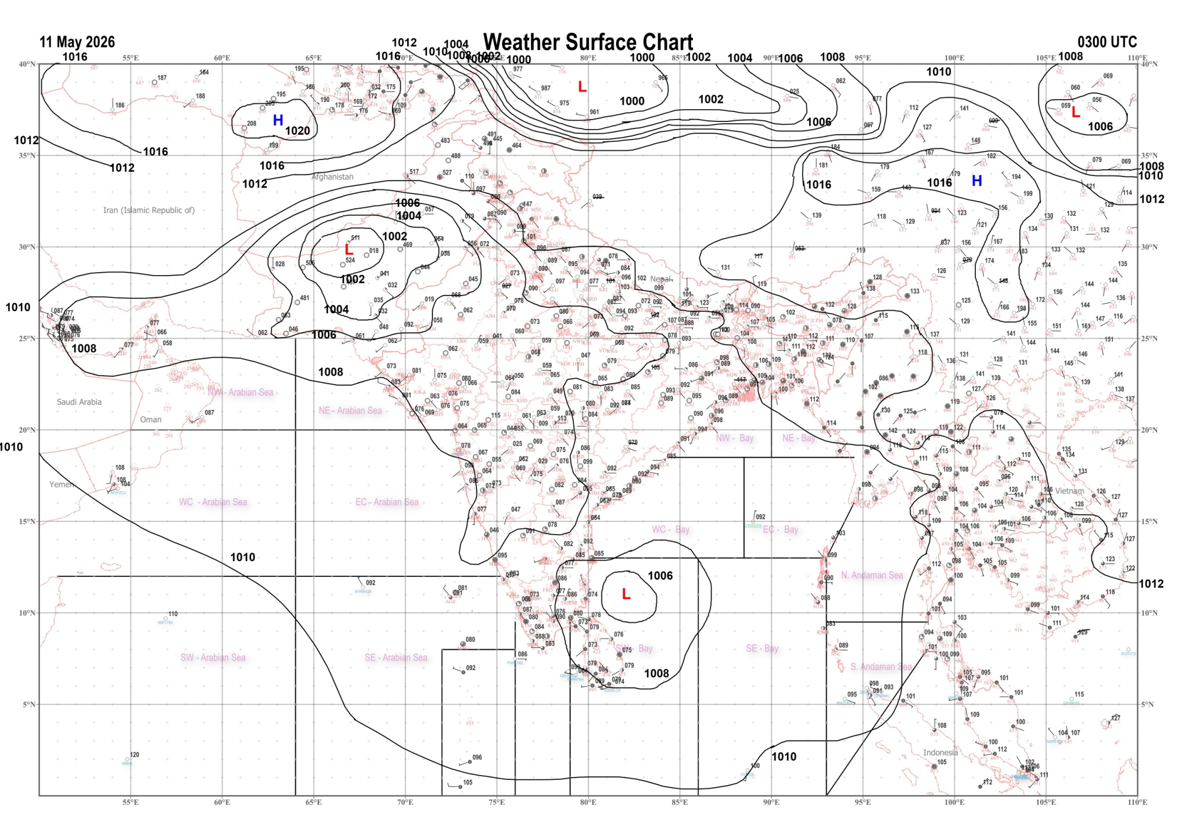 | 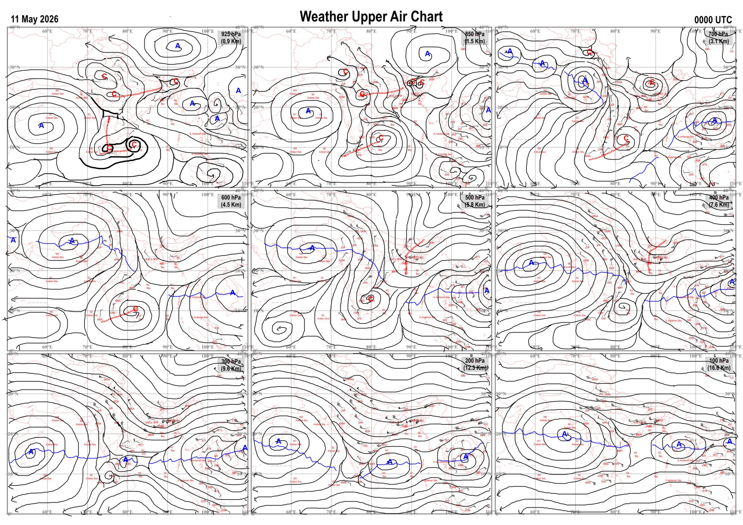
Fig.1. Analysed surface chart based on 03z observation | Fig.2. Analysed upper air chart based on 00z observation
Dr. S.D.Sanap.
Scientist ‘D’
CR & S Office, Pune  Issued at 1245 hrs. IST |  | Weather Forecasting Division  CR&S, Pune

Indian regions | Realised rainfall (chief amount in cm during past 24 hrs):
East | many places: Arunachal Pradesh  a few places: Assam & Meghalaya and Nagaland-Manipur-Mizoram-Tripura  isolated places: Sub-Himalayan West Bengal & Sikkim◆, Gangetic West Bengal, Odisha++, Jharkhand and Bihar  Bhuban 13.2, Bhanjnagar 4.9, D / Mohanbari AP 4.8, Namsai 4.7, Ranchi AP 4.6, Nahar katia, Jorhat, Mokokchang & Wokha AWS 3.7 each, Deomali AWS 3.1, Agartala AP 2.4, Tezu 2.3, Digha 1.7, Icar namkum 1.5, Banmankhi 1.3, Ghagra 1.2, Diamond harbour 0.7, Keonjhargarh 0.5, Bankey bazar 0.3, Rongli 0.2, Tra nagrakata & Malda 0.1 each.
North | most places: Himachal Pradesh  a few places: Jammu-Kashmir and Ladakh  isolated places: Uttarakhand, Haryana, Punjab and west Rajasthan  dry weather: Uttar Pradesh and east Rajasthan  Phangota 5.4, Guler & Pandoh 4.1 each, Jammu AWS 2.8, Malikpur, Bhuntar AP & Jammu 2.6 each, Poonch 2.1, Mori, Uttar kashi & Sirsa AWS 0.5 each, Sangaria SR & Tibi SR 0.4 each, Loharkhet 0.3, Naraingarh 0.2, Amritsar 0.1.
Central | isolated places: Chhattisgarh  dry weather: Madhya Pradesh and Vidarbha  Dornapal 1.0, Jagargunda 0.7.
Peninsula | isolated places: Konkan & Goa◆, coastal Andhra Pradesh, Telangana, Rayalaseema, Tamil Nadu, coastal Karnataka, interior Karnataka and Kerala  dry weather: Gujarat State, Madhya Maharashtra and Marathwada  Angadipuram 5.3, Harapanahalli 4.7, Konni ARG 3.6, Paderu 3.2, Narsipatnam & Owk 2.2 each, Orvakal & Chittar 1.6 each, Kurunthancode 1.3, Pebbair 1.2, Gangavathi & Jayapura 0.9 each, Ankola & Chitradurga 0.7 each, Shirahatti 0.6, Karwar & Mudubidre 0.5 each, Nagar kurnool & Anantpur 0.4 each, Tuni & Vedaranyam 0.3 each, Canacona & Haveri PTO 0.1 each.
Islands | isolated places: Andaman & Nicobar◆ and Lakshadweep◆  Iaf carnicobar & Minicoy 0.1 each.
Table-2 Forecast / warnings (distribution of rain / thundershowers) for 7 days (valid from time of origin upto 0830 hrsIST of next day)
Sr N. |  | Sub-division Name | Day 1 | Day 2 | Day 3 | Day 4 | Day 5 | Day 6 | Day 7 | Sr. No. | Sub-division Name | Day 1 | Day 2 | Day 3 | Day 4 | Day 5 | Day 6 | Day 7
 |  |  | 11 May | 12 May | 13 May | 14 May | 15 May | 16 May | 17 May |  |  | 11 May | 12 May | 13 May | 14 May | 15 May | 16 May | 17 May
 | 1 | Andaman Nicobar Islands | F  | F  | F  | F +  | F +  | F +  | F  | 19 | west Madhya Pradesh | D | D + | D + | D + | D + | D | D
 | 2 | Arunachal Pradesh | S | S  | F +  | F +  | W +  | W + | W ++ | 20 | east Madhya Pradesh | D | D | D | D | D | D | D
 | 3 | Assam-Meghalaya | F  | F +  | F++ | W++ | W++ | W ++ | W ++ | 21 | Gujarat region | D + | D + | D + | D + | D | D | D
 | 4 | Nagaland-Manipur-Mizoram-Tripura | S  | S  | S  | S  | F +  | F + | F + | 22 | Saurashtra and Kutch | D + | D + | D + | D + | D | D | D
 | 5 | Sub Him West Bengal/Sikkim | S  | W +  | W +  | W +  | F  | F | F | 23 | Konkan and Goa | I  + | D | D | D | D | D | D
 | 6 | Gangetic West Bengal | I  | S  | S  | S  | I | I | I | 24 | Madhya Maharashtra | I  | D + | D + | D | D | I | D
 | 7 | Odisha | I  | I  | I  | I  | I  | I | I | 25 | Marathwada | I | D + | D + | D | D | I | D
 | 8 | Jharkhand | I  | I  | S  | I  | S  | I  | I  | 26 | Vidarbha | D | D | D | D + | D + | D | D
 | 9 | Bihar | I  | S  | I  | I  | I  | I | I | 27 | Chhattisgarh | D | D | I  | I  | I  | I | I
 | 10 | east Uttar Pradesh | D | I  | I  | D | D | D | D | 28 | Coastal Andhra Pradesh and Yanam | I  | I  | I  | I  | I  | I | I
 | 11 | west Uttar Pradesh | I  | I  | D | D | D | D | D | 29 | Telangana | I  | I  | D | D | D | D | D
 | 12 | Uttarakhand | S  | F  | F  | S  | I | I | I | 30 | Rayalaseema | I  | I | I | I | I | I | I
 | 13 | Haryana,Chandigarh and Delhi | I  | I  | I  | I  | I  | D | D | 31 | Tamil Nadu, Puducherry and Karaikal | I  | I  | I | I  | I | I | I
 | 14 | Punjab | I  | I  | I  | I  | I  | D | D | 32 | Coastal Karnataka | I | I  | I  | I  | I  | I | I
 | 15 | Himachal Pradesh | S  | F  | F  | S  | S  | S | I | 33 | North interior Karnataka | I  | I  | I  | I  | I  | I | I
 | 16 | Jammu-Kashmir and Ladakh | W  | W  | S  | S  | I | I | D | 34 | South interior Karnataka | I  | I  | I  | S  | S +  | S + | I
 | 17 | west Rajasthan | I  + | I + | D + | D + | D + | D + | D + | 35 | Kerala and Mahe | F  | F  | F  | F +  | W +  | W + | W +
 | 18 | east Rajasthan | I  + | I  + | D + | D | D | D | D | 36 | Lakshadweep | F  | F  | F  | F  | F  | F | F
Legends: D = Dry I =isolated S = Scattered F = Fairly widespread W = Widespread #= heavy to very heavy rain at a few places with extremely heavy rain at isolated places+++= heavy rain at a few places with very heavy rain at isoIated places++= heavy to very heavy rainfall @=isolated exceptionally heavy rainfall+ = heavy rain ●/*= rain or snow ♦ = very light rain ≡=fog = thunderstorm with lightning =Squall / Gusty / gale / strong wind -=cold wave/cold day + = heat wave/warm night/hot and humid weather =Duststorm =ground frost = Hail.
Fig. 4: Districtwise warnings for five days for Maharashtra State
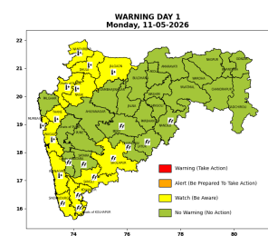 | 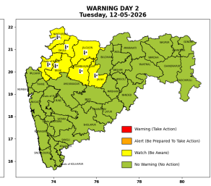 | 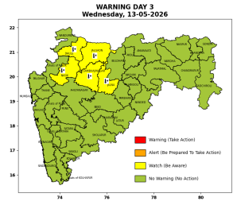 | 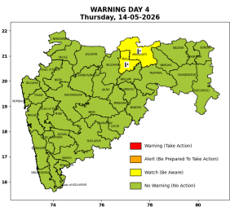 | 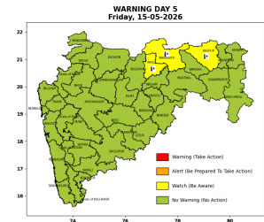

Pune, Lohegaon and Pashan observations at 0830 hrs. IST of Today
 | Temperature (°C) |  |  |  |  | Humidity (%) |  |  |  | Rainfall (mm)
 | Max.  past  24 hrs | Dep.  from  normal | Min.  past  24 hrs. | Dep.  from  normal | Dry  Bulb | At 0830 hrs. IST | Dep.  From  normal | At 1730  hrs. IST of y’day | Dep.  from  normal | Past  24 hrs. | Since  1st March | Dep.  from  normal
PNE | 41.6 | 4.1 | 26.3 | 4.0 | 31.2 | 32 | -23.0 | 32 | -2.0 | 0.0 | 92.8 | 72.3
PSN | - | - | 24.2 | 1.9 | 28.4 | 51 | -4.0 | - | - | - | - | -
LHG | 42.8 | 5.8 | 27.0 | 6.0 | 29.9 | 36 | -22.0 | 10 | -22 | 0.0 | 91.4 | 65.3

 |  |  |  |  |  |  | Local (Pune and neighbourhood) forecast
Max./Min. Temperature (°C) |  |  |  |  |  |  |  |  | Weather
Date | Pune | Pashan | Lohegaon | Chinchwad | Lavale | Magarpatta | NDA | Koregoan park
11/05/26 | 42 / 24.8* | 41 / - | 43/ 27.6* | 41 / - | 40 / - | 41 / 28.2* | 39 / 23.8* | 42 / - | Mainly clear sky becoming partly cloudy sky towards evening.
12/05/26 | 42 / 25 | 41 / 24 | 43 / 28 | 41 / 27 | 40 / 24 | 41 / 28 | 39/ 24 | 42 / 28 | Mainly clear sky.
13/05/26 | 41 / 24 | 40 / 23 | 42 / 28 | 40 / 26 | 39 / 23 | 40 / 27 | 38 / 23 | 41/ 28 | Mainly clear sky.
14/05/26 | 41 / 24 | 40 / 23 | 42 / 28 | 40 / 26 | 39 / 23 | 40 / 27 | 38 / 23 | 41 / 28 | Mainly clear sky.
15/05/26 | 40 / 25 | 39 / 24 | 41 / 29 | 39 / 27 | 38 / 24 | 39 / 28 | 37 / 24 | 40 / 29 | Mainly clear sky.
16/05/26 | 40 / 25 | 39 / 24 | 41 / 29 | 39 / 27 | 38 / 24 | 39 / 28 | 37 / 24 | 40 / 29 | Mainly clear sky.
17/05/26 | 39 / 25 | 38 / 24 | 40 / 29 | 38 / 27 | 38 / 24 | 38 / 28 | 37/ 24 | 39 / 29 | Mainly clear sky.
Rainfall Distribution |  |  |  |  | Rainfall Categories | Rainfall (mm) | Cloud condition |  | Rainfall Intensity | Range
Widespread (W) | 76-100% |  |  |  | Very Light rain | Trace to 2.4 mm | Mainly clear sky | 1-2 oktas | Light Spell | 1 cm/hr
 |  |  |  |  | Light rain | 2.5 to 15.5 mm | Partly cloudy sky | 3-4 oktas | Moderate Spell | 1-2 cm/hr
Fairly Widespread (FW) | 51 – 75% |  |  |  | Moderate rain | 15.6 to 64.4 mm | Generally cloudy sky | 5-7 oktas | Intense Spell | 2-3 cm/hr
Scattered (S) | 26 – 50% |  |  |  | Heavy rain | 64.5 to 115.5 mm | Overcast | 8 oktas | Very Intense Spell | 3-5 cm/hr
Isolated (I) | 1 – 25% |  |  |  | Very heavy rain | 115.6 to 204.4 mm |  |  | Extremely Intense Spell | 5-10 cm/hr
Dry (D) | No Rain |  |  |  | Extremely heavy rain | ≥ 204.5 mm |  |  | Cloudburst | > 10 cm/hr
Probability Terms in %: |  |  |  |  | Heavy snow | 6.5 to 11.5 cms water equivalent of rain
unlikely | < 25 |  |  |  | Very heavy snow | 11.6 to 20.4 cms water equivalent of rain
likely | between 25 50
very likely | between 51 75
most likely | >75
* = realized temperatu
Mumbai (Colaba) |  |  |  | Nagpur (AP)
Date 2026 | T max °C | T min °C | Weather | T max °C | T min °C | Weather
11/05/26 | 35 | 27 | Mainly clear sky. Hot and Humid. | 43 | 24 | Partly cloudy sky.
12/05/26 | 34 | 27 | Clear sky. | 44 | 25 | Partly cloudy sky.
13/05/26 | 34 | 26 | Clear sky | 44 | 26 | Partly cloudy sky.
14/05/26 | 35 | 26 | Clear sky | 44 | 26 | Mainly clear sky .
15/05/26 | 35 | 26 | Clear sky | 45 | 27 | Mainly clear sky. Heat Wave
16/05/26 | 34 | 25 | Clear sky. | 44 | 26 | Partly cloudy sky .
17/05/26 | 34 | 25 | Clear sky. | 44 | 26 | Partly cloudy sky.

